The software development group at Abphina is proud to present our progress on VitalBlinks®, a business simulation game. VitalBlinks® provides a learning platform for users, ranging from business students to corporate management, to individual entrepreneurs. This game enables these future leaders to gain a better understanding of the intricacies of the biopharmaceutical industry through hands-on experience in dealing with the challenges that they may encounter in real-life situations. By bringing the extensive pharmaceutical expertise of Abphina into an engaging and tech-driven product, we hope to make an increasing positive impact on the biopharma world.

VitalBlinks® is currently in its early development phase, as the general structure of the program is being defined. Our team’s goal is twofold: to detail the software specifications, and to create preliminary user interface (UI) mappings. Software specifications take into consideration a variety of factors, including system and software interfaces, product functions, and more. The UI mappings aim to provide an intuitive, comfortable and attractive user experience. Both must be carefully merged to ensure that form and functionality flow together seamlessly.

[Avinash Gyawali](mailto:ag8093@nyu.edu)

I study computer science and interactive media at New york university abu dhabi in the United Arab Emirates.I am a Unity game developer passionate about making games.During my free time , I am also involved in research about virtual reality and haptics technology.As a game developer, I am committed to delivering experiences that inspire, entertain, and challenge players. I believe in the power of games to transport us to new worlds, foster empathy, and ignite our imagination and insatiable curiosity for learning.

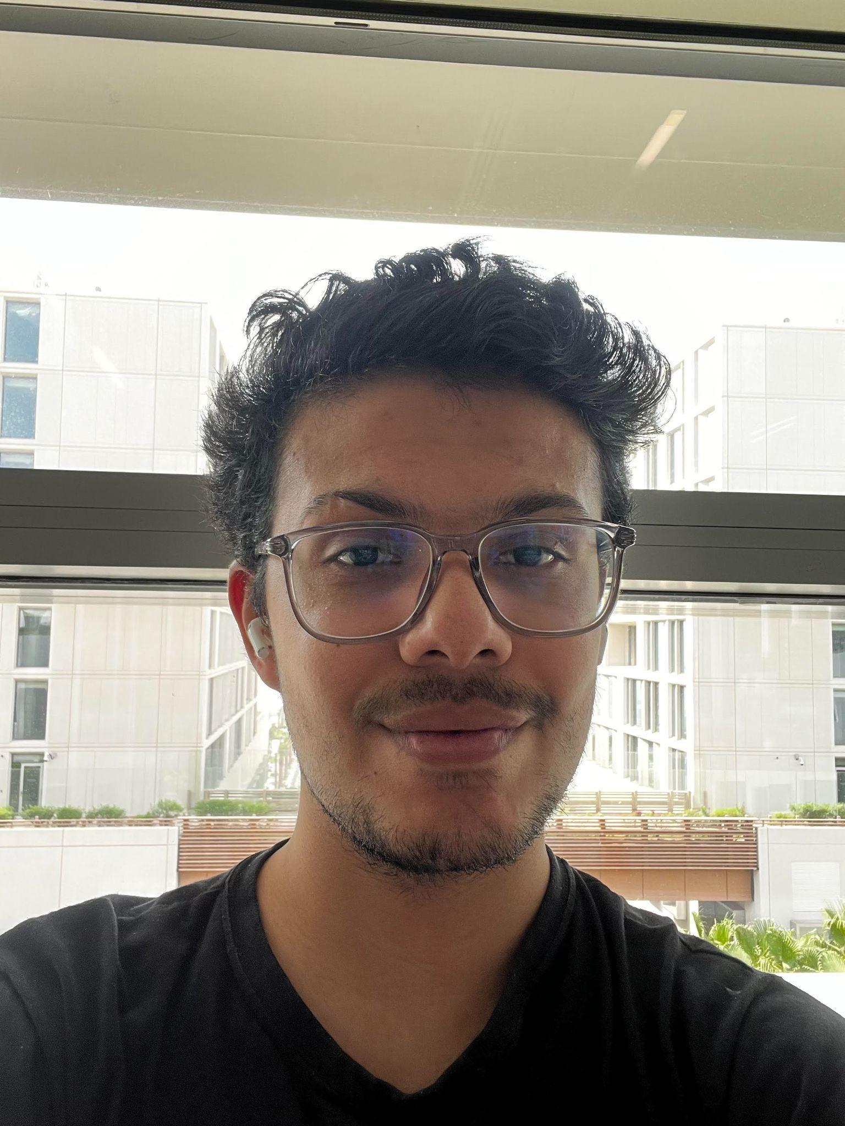

***Joshua Tan***

I study Computer Science at New York University Shanghai in China. My interests are in systems programming and parallel computing, but I also enjoy biology, economics, psychology, and other social sciences. I am fortunate to have the opportunity to bring together these various disciplines in this internship, and I hope that this experience will provide practical insight into each of these fields.



***David De La Cruz***

I’m currently a college student going for a Bachelor’s of Science in Computer Science at California State University, San Bernardino. I enjoy all software development but have a strong interest in game programming. Abphina caught my interest because it offered a challenge in developing a completely new game with an intriguing end-goal. With my knowledge and experience of both video games and software development, it was an opportunity I couldn’t pass up. I’m happy to be part of such a great company!

